**Garden Club of Harrington Park**

**2024-2025 Meetings and Events**

*The Garden Club or Harrington Park holds General Meetings the first Thursday of every month (except where otherwise noted) September through June in the Harrington Park Library (second floor). The meetings begin at 7:30 P.M. and include a lecture by a guest speaker on various gardening topics, followed by a Q & A, and refreshments. Each meeting we have a floral contest, whereby members interpret a given theme.*

*Traditionally, in June we have a field trip and luncheon, and on occasion, we have mini-field trips to a garden, a garden show, anything garden!*

**September 5, 2024**

Speaker: Nisha Khanna, landscape designer and garden coach/consultant who runs her business "Growing Gardens" in Edison, NJ.

Topic: "Container Gardening”

**October 3, 2024**

Speaker: John Beirne, Curatorial Director of Horticulture & Facilities, Reeves Reed Arboretum

Topic:

**November 7, 2024**

Speaker: Robyn Lowenthal, Master Gardener

Topic: “All About Coleus”

**November 17, 2024** – 2:00 P.M.

“Thanksgiving Centerpiece Workshop” –Conducted by Gerri Gibney – Fee $23.00 Members, $28.00 Non-Members

Pre-Registration Required – contact [themerchantmouse@aol.com](mailto:themerchantmouse@aol.com) or

201 768-2615

**December 5, 2024**

Speaker: Gerri Gibney

Topic: Hands on Workshop

Wreath and Holiday Arrangements

Make-It and Take-It

**December 13, 2024**

Garden Club Holiday Get-Together – Pot Luck “Nibbles and Sweets” at Gerri Gibney’s – 7:00 P.M.

**January 2, 2025**

Chair: Esther Ross

“Members’ Night & Winners & Losers in the Garden” – A Fun Evening of Garden Club Members’ “Power Point Show and Tell” of Their Own Gardens, Gardens Visited, or Anything Garden

**February 6, 2025**

Speaker: Christine Kozar, Master Gardener

Topic: “Getting Ready for Spring”

**March 6, 2025**

Speaker: TBD

Topic: TBD

Note: Reached out to Iris Association & Leonard Buck Gardens for speakers

**April 3, 2025**

Speaker: Paul Kubarych, Landscape Architect, Lecturer

Topic: “Garden Design”

**April 26, 2025** – Garden Club Plant Sale (Many Homegrown Plants) – Annual Fundraiser 9:00 A.M.–

1:00 P.M.

**May 1, 2025** – ***Garden Club Plant Swap***

Speaker: Mary Jo Sichak, Master Gardener

Topic: “Indoor Gardening”

**June 7, 2025**  – 10:00 A.M.

Tour of Members’ Gardens and Pot Luck Barbecue

**June 21, 2025** – Annual Field Trip & Luncheon

Depart Library Parking Lot at 9:00 A.M. – Leonard Buck Gardens, Far Hills, N.J., Docent Led Tour, Luncheon to Follow

***Celebrating Our 35th Anniversary in May 2025!***



**Garden Club of Harrington Park**

**Membership**

Membership is open to anyone with a love of gardening. Whether you are an arm chair gardener or an on your knees dirt gardener – we welcome all. Incidentally, we have both men and women members in our Club – we were one of the first garden clubs in New Jersey to have both, because, since our inception we have met in the evening! You do not have to be a resident of Harrington Park, many of our members are from surrounding towns.

Our dues are:

Individual - $20.00

Family - $35.00

If you are interested in becoming a member of the Garden Club, please send your check, made payable to the Garden Club of Harrington Park, to Beverly Murray, 363 High St., Closter NJ 07624-2004. Please include your address, phone number, and e-mail.

**Opportunities for Fun**

You can enjoy the Garden Club in so many ways; by attending our meetings, and/or volunteering to be a refreshment host and helping with special events.

This Club year we plan to have a Spring Plant Sale for our fundraiser. This will need helping hands too.

**Affiliations**

We are members of the Garden Club of New Jersey and the Garden Club of America.

***Information about the Garden Club, please call Gerri Gibney at 201 768-2615 or 201 913-8459,*** [***themerchantmouse@aol.com***](mailto:themerchantmouse@aol.com) ***– We’re on Facebook – friend us!***

[***www.gardenclubofharringtonpark.com***](http://www.gardenclubofharringtonpark.com)

**NOTES**

**Garden Club**

**of**

**Harrington Park**

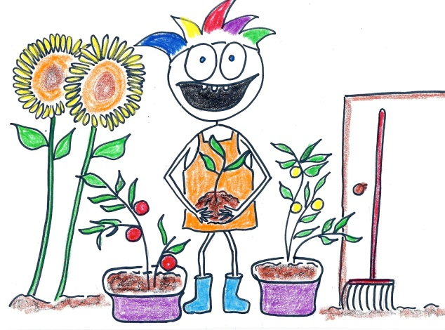

**Meetings**

**and**

**Events**

**2024 - 2025**